static Routing with 4 routers

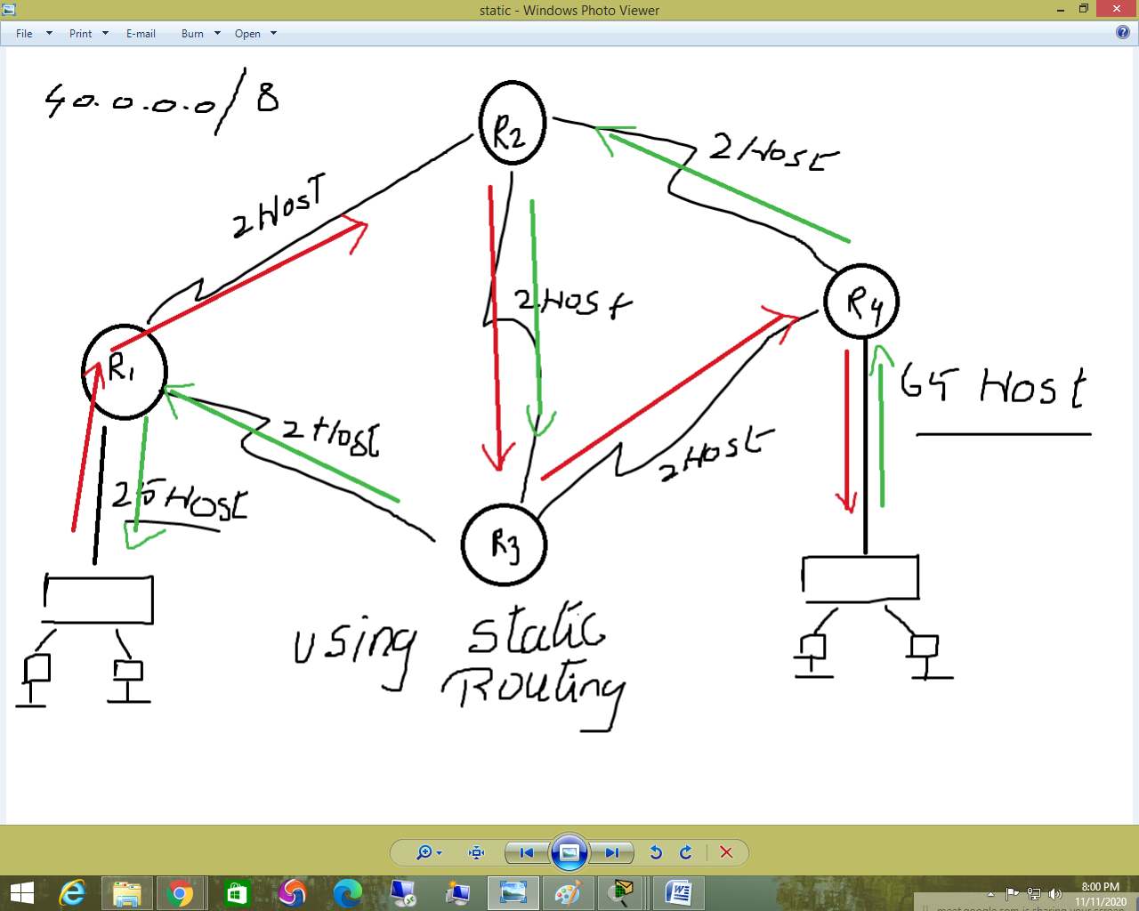

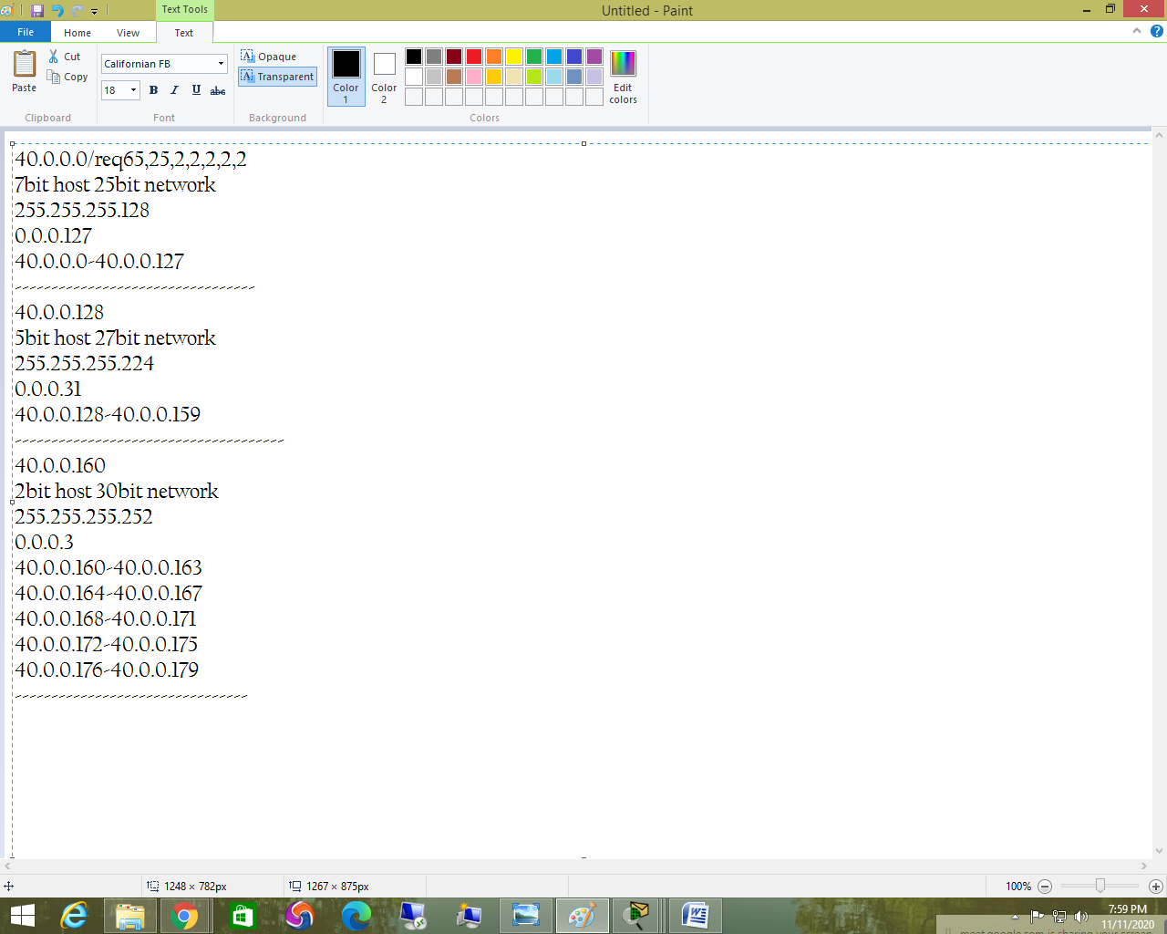

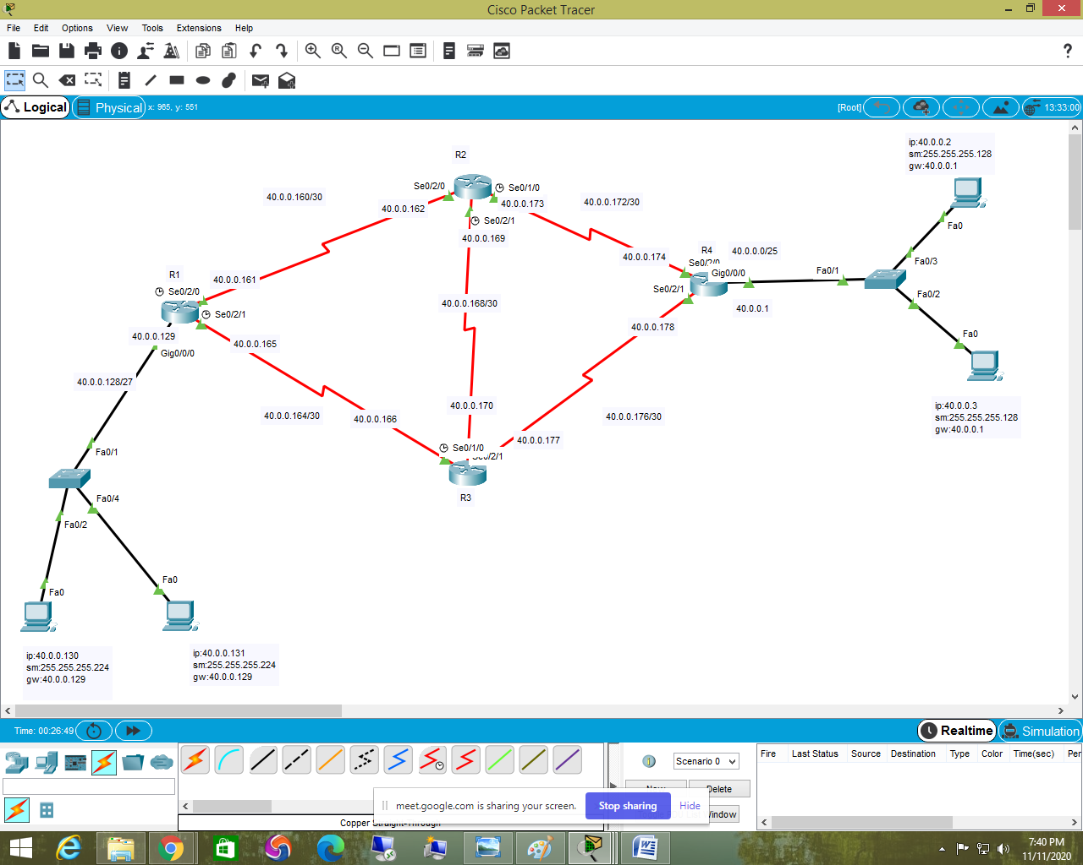

R1 interface configuration

Router>enable

Router#configure terminal

Router(config)#hostname R1

R1(config)#interface g0/0/0

R1(config-if)#ip address 40.0.0.129 255.255.255.224

R1(config-if)#no shutdown

R1(config-if)#interface se0/2/0

R1(config-if)#ip address 40.0.0.161 255.255.255.252

R1(config-if)#no shutdown

R1(config-if)#interface se0/2/1

R1(config-if)#ip address 40.0.0.165 255.255.255.252

R1(config-if)#no shutdown

----------------------------------------------------------

R2 interface configuration

Router>enable

Router#configure terminal

Router(config)#hostname R2

R2(config-if)#interface se0/2/0

R2(config-if)#ip address 40.0.0.162 255.255.255.252

R2(config-if)#no shutdown

R2(config-if)#interface se0/2/1

R2(config-if)#ip address 40.0.0.169 255.255.255.252

R2(config-if)#no shutdown

R2(config-if)#interface se0/1/0

R2(config-if)#ip address 40.0.0.173 255.255.255.252

R2(config-if)#no shutdown

--------------------------------------------------------------

R3 interface configuration

Router#configure terminal

Enter configuration commands, one per line. End with CNTL/Z.

Router(config)#hostname R3

R3(config-if)#interface se0/2/1

R3(config-if)#ip address 40.0.0.170 255.255.255.252

R3(config-if)#no shutdown

R3(config-if)#interface se0/2/0

R3(config-if)#ip address 40.0.0.166 255.255.255.252

R3(config-if)#no shutdown

R3(config-if)#interface se0/1/0

R3(config-if)#ip address 40.0.0.177 255.255.255.252

R3(config-if)#no shutdown

--------------------------------------------------------

R4 interface configuration

Router>enable

Router#configure terminal

Router(config)#hostname R4

R4(config)#interface se0/2/0

R4(config-if)#ip address 40.0.0.174 255.255.255.252

R4(config-if)#no shutdown

R4(config-if)#interface se0/2/1

R4(config-if)#ip address 40.0.0.178 255.255.255.252

R4(config-if)#no shutdown

R4(config-if)#interface g0/0/0

R4(config-if)#ip address 40.0.0.1 255.255.255.128

R4(config-if)#no shutdown

====================================================================

static routing for 40.0.0.0/25

configuring in R1

R1(config)#ip route 40.0.0.0 255.255.255.128 40.0.0.162

configuring in R2

R2(config)#ip route 40.0.0.0 255.255.255.128 40.0.0.170

configuring in R3

R3(config)#ip route 40.0.0.0 255.255.255.128 40.0.0.178

--------------------------------------------------------------------------------------------------------------------

static routing for 40.0.0.128/27

configuring in R4

R4(config)#ip route 40.0.0.128 255.255.255.224 40.0.0.172

configuring in R2

R2(config)#ip route 40.0.0.128 255.255.255.224 40.0.0.170

configuring R3

R3(config)#ip route 40.0.0.128 255.255.255.224 40.0.0.165

------------------------------------------------------------------------------------------------------------------------

to check static Routing

show ip route=to check routing table